## From Grief to Growth: Why Joseph Tito’s *Random Thoughts* Isn’t Just a Book—It’s a Movement

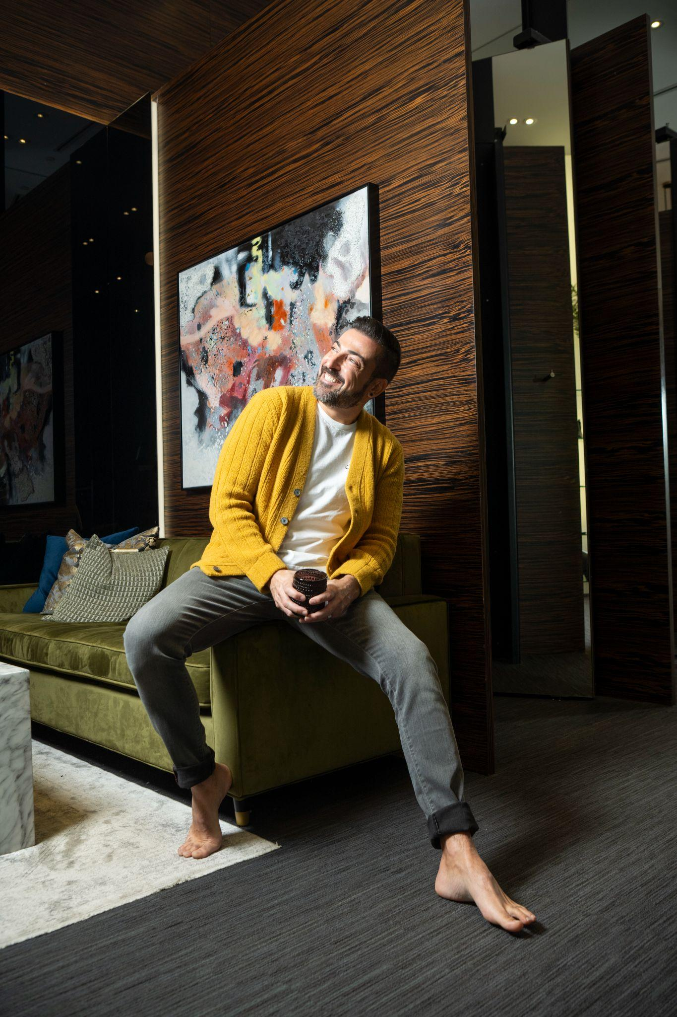

Photography by Josephine Gennaro

**FOR IMMEDIATE RELEASE**

**Toronto, ON —** In an age where perfection is curated and vulnerability is often filtered, Joseph Tito’s *Random Thoughts: The Shit We Don’t Talk About* arrives like a deep exhale we didn’t know we needed. Releasing May 15 in print and digital formats, this raw, funny, and fiercely human book doesn’t just share stories—it sparks a much-needed cultural reckoning with truth.

At once a memoir, manifesto, and mental health survival kit, *Random Thoughts* is a mirror for anyone navigating the mess of modern life—parenthood, queerness, midlife pivots, burnout, identity, grief, and the million ways we try to hold it all together. But what makes it transformative isn’t just Joseph Tito’s unfiltered storytelling—it’s how he weaves his intersectionality into something universal.

“Most people aren’t just one thing,” says Tito. “We’re parents and dreamers, hot messes and healers, queer and questioning and quietly hopeful. I wrote this book for all those who feel like they’re too much, not enough, or both at once.”

A former filmmaker-turned-content creator, Tito built a fiercely loyal global following through *The Dad Diaries*, a digital diary-turned-community that documents the joys and struggles of life as a gay father of twins. But this book goes deeper. In chapters like *“Whiskey, Meds, and the Art of Survival,” “Two Dads, A Dog, and the PTA,”* and *“The Smile That Stops a Meltdown,”* he permits readers to be messy, to laugh at the absurdity, and to admit when they’re struggling—all without shame.

Launching during Mental Health Awareness Month and ahead of Pride and Father’s Day, *Random Thoughts* enters a world hungry for truth. In a time where people increasingly feel like they’re living in silos—cut off from connection, overwhelmed by expectation, and unsure where they belong—Tito reminds us that the walls we build around ourselves are meant to be broken.

What sets this book apart isn’t just its relatability—it’s its reach. Tito doesn’t write *to* audience segments—he writes *through* them. His words speak just as clearly to suburban moms as they do to LGBTQ+ dads, to spiritual seekers, anxious overachievers, and anyone who’s ever looked in the mirror and wondered, “Am I doing this right?”

Tito stitches together a narrative that resonates across identities through humor, heartbreak, and radical honesty. He doesn’t claim to have the answers, but he’s unafraid to ask them out loud. In doing so, he creates space for others to exhale, too.

“This isn’t a guide to being a perfect parent, or a perfect queer person, or a perfect anything,” Tito adds. “It’s a reminder that real connection comes from sharing what we usually hide. And if this book helps someone feel a little less alone in their chaos, it’s done its job.”

In an increasingly disconnected world, *Random Thoughts* isn’t just a book—it’s a bridge.

Learn more about the book launch party and [pre-order the book here](https://thedaddiaries.com/random-thoughts-the-shits-we-dont-talk-about/).

**About Joseph Tito**

Joseph Tito is the creator of *The Dad Diaries*, a filmmaker-turned-content creator, and a proud LGBTQ+ dad to twin girls. Known for his unfiltered storytelling and raw honesty, Joseph has built a global community by sharing the beautiful chaos of parenting, identity, and emotional growth. His debut book, *Random Thoughts: The Shit We Don’t Talk About*, is a bold, heartfelt exploration of the mess and magic of modern life. He lives in Toronto with his husband and daughters.

**Media Contact**

Nadya Rousseau  
nadya@alternewmedia.com  
+1 (310) 912-7475